CONFIDENTIAL

P510/3/Inst. Sc

PHYSICS

PRACTICAL

INSTRUCTIONS

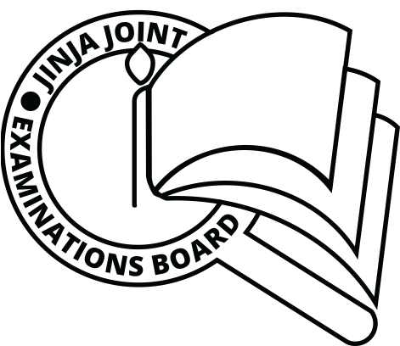Paper 3

AUGUST, 2019

JINJA JOINT EXAMINATIONS BOARD

Uganda Advanced Certificate of Education

MOCK EXAMINATIONS – AUGUST, 2019

PHYSICS

PRACTICAL

INSTRUCTIONS

Paper 3

CONFIDENTIAL:

GREAT CARE SHOULD BE TAKEN THAT THE INFORMATION GIVEN BELOW DOES NOT REACH THE CANDIDATES EITHER DIRECTLY OR INDIRECTLY.

In addition to apparatus and equipment ordinarily contained in a physics laboratory, each candidate will require the following:

**QUESTION 1.**

1 Retort stand and clamp

1 Metre rule

4 Glass marbles

2 Wooden blocks each measuring about 5.0cm x 3.0cm x 3.0cm

3 Pieces of thread each of length 50.0 cm

1 Knife edge

1 Transparent polythene paper bag (kaveera) used for measuring  or kilogram mass in shops

**QUESTION 2.**

1 Glass block

2 Office pins

1 Optical pin

2 Plain sheets of photocopy paper

1 Soft board

1 Mathematical set

**QUESTION 3.**

1 Ammeter (0 – 1A)

1 Dry cell in a holder

1 Switch labelled K

1 Centre-zero galvanometer

1 Jockey

1 Metre bridge

9 Pieces of connecting wire each about 50 cm long

2 Crocodile clips

2 Two ohm standard resistors labelled R1=2 and R2=2 

1 Piece of bare constantan wire (SWG 28) labelled W, of length 80.0 cm